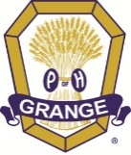
2023 Family Festival MEALS
Any items are subject to change

Thursday Dinner
(Provided by Penns Valley Grange #158)
Spaghetti and Meat Sauce; Garlic Bread
tossed salad and Dessert

Friday; Saturday; Sunday Breakfast
Pancakes-French Toast/Syrup/Butter
Scrapple/Sausage/Bacon
Eggs made to order
Toast; English Muffins; Bagels
Milk; OJ; Coffee; Hot Tea
Cold Cereal
Fruit

Friday Lunch
Hoagies — Ham; Hard Salami; Bologna;
Tuna Salad; Tossed Salad
Fresh Fruit
Pickles; Pickled Eggs—Red Beets
Nacho’s & Cheese
Pudding; Dessert

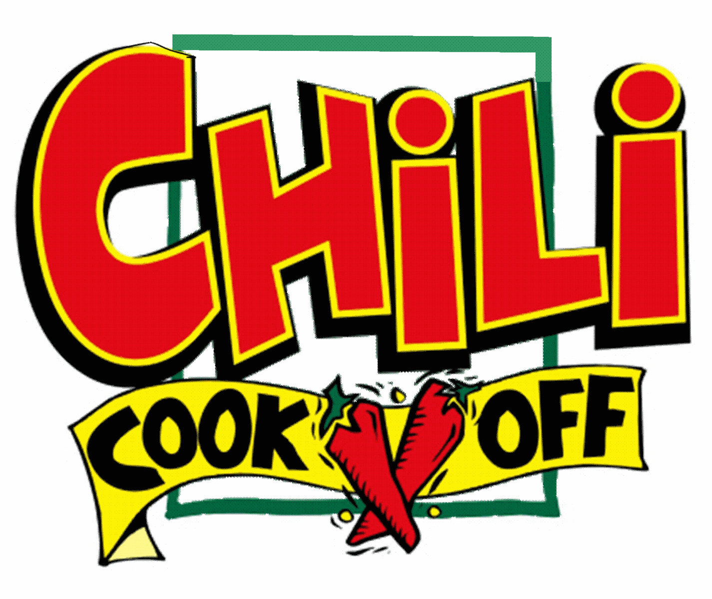
Friday Dinner
(Provided by Youth Dept.)
Hot Dogs
Baked Potatoes
Chili from Cook-Off
Tossed Salad; Cookies

Saturday Lunch
(Provided by Logan Grange #109)
Taco Salad; Tossed Salad
Grilled Cheese;
Tomato Soup
Applesauce;
Pudding & Dessert

Saturday Dinner
(Provided by Baileyville Grange #1991)
Pulled Pork Sandwich (prepared in a Bacon Wrap)
Variety of BBQ sauces on side
Baked Beans
Cole Slaw
Macaroni Salad
Tossed Salad
Strawberry Shortcake
Family Festival News—

Family Festival 2023 will be held July 13th thru 16th. This is the 19th year of Family Festival which started in 2004. There will not be a theme for this year's event, but the stage will be decorated to highlight our 150th Anniversary celebration.

Please fill out and return the form located in this issue of the PGN to attend. We have limited the number of workshops in response to the surveys asking for more free time.

Workshops—
Barb and Glenn Gross – Quilt Block painting workshop, Amy Koenig – Ribbon Christmas craft workshop
Jenn Nauss, State Lecturer – Paint and Sip event
Tina Keen, D&CS Director – Sign Language
Carrie Nace, Legislative Consultant – Legislative issues
and how you can make a difference.
The Youth Department — Parli-Pro.

There will be a change in how the meals are being prepared. Several Granges in Centre County have offered to serve some of the meals. See the lunch menu for more information.

Breakfast and Friday lunch will be done by the "old" crew.

Friday afternoon will be water games and Saturday will be filled with fun events for the Juniors, Youth, and Youth at heart.

There will be information available at registration on local points of interest for you to visit or partner with others to visit those places in Centre County you always wanted to visit.

2023 People's Choice Festival of PA Arts and Crafts will also be going on providing another venue for you to visit right there on the Fairgrounds. Google peopleschoicefestival.com for more information

Stay tuned to social media and Constant Contact for additional details as they become available. We look forward to seeing you in July for another great Family Festival event.
