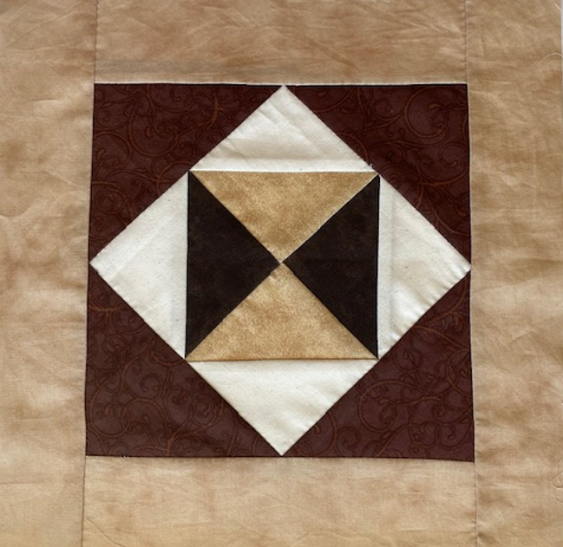
Pennsylvania State Grange

2022-2023 Guide to Contests

FAMILY ACTIVITIES

Cindy Schlegel, Co-Director  33 E. Weis St.  Topton, PA 19562-1217  610.641.0070  clbasket@ptd.net | Evelyn Cottrell, Co-Director  750 Cottrell Rd  Thompson, PA 18465-9591  570.727.2995

All entries must be made within the current Grange year, but in time for your local judging.

Entering:
- All contests are open to all Subordinate and Junior Grange members, and will be judged together, male and/or female.
- Work must be entirely that of the contestant’s name on the label.
- Enter as many contests as you wish, only ONE entry in each class.
- NO STRAIGHT PINS – if an entry contains straight pins, it will be disqualified, use Safety Pins only.

Judging:
- Entries are to be judged at the Subordinate Grange level unless every Subordinate Grange in one Pomona chooses to have all their entries judged at the Pomona level.
- If you do have Subordinate Grange judging, the first-place entry would then be sent to the Pomona for judging.
- First place winners at the Pomona level will be sent to State Session in October to be judged.
- SEND all Quilts and Quilt Blocks to State Session for judging. They may be judged on the Subordinate and Pomona level if you wish to give recognition to those who entered them. However, regardless of placing, send ALL to State Session for judging there.
- If there are only one or two entries, they will be awarded first and second place with the first-place winner being sent on to the next level for judging. This has always been, and still is the policy of the Grange.

Awards:
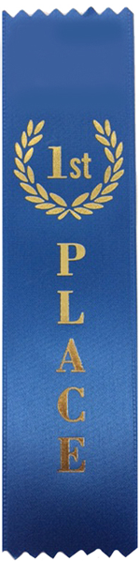
- Ribbons and cash awards will be presented in each contest at the state level. In case there is a tie, the level of difficulty will determine the winner. The decision of the judges is final.
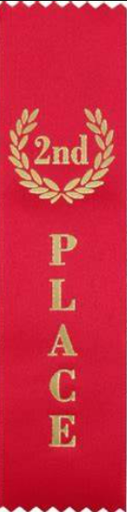
1st. Place – Blue Ribbon - $20.00
2nd Place – Red Ribbon - $15.00
3rd Place – White Ribbon - $10.00

Labeling:
- Please include the following information on the designated paper label before attaching it to the entry:
- DO NOT sew the label on the entries, fold the label over and please use safety pins.

Inside Label:  Name  Address  Telephone number with Area Code  Grange Name and Number | Outside of Label:  County Name  Contest Title  Class Number
Please use the designated label on all entries.
QUILT BLOCKS
Class 1: 2023 Triangles and Rectangles
Pieced - Color scheme – Brown/Creams/Earth Tones

Must be 12½" X 12½" finished square, which includes ¼" seam allowance.
- Must be the designated pattern and color scheme as shown on the instruction sheet.
- Must be 100% cotton.
- Wash fabric before using to control bleeding and shrinkage.
- Judging of TOP only!!
- All blocks are to be sent to state session for judging. Subordinate and Pomona elimination is not necessary.
- Blocks WILL NOT be returned. They will be used by the Family Activities for future quilts.
- Entries will be judged on workmanship, creativity and general appearance.

QUILT CONTEST
Division A Quilt - Minimum 60" X 60" – Maximum 120" X 120"
Class 2 Quilts entirely hand quilted by an individual
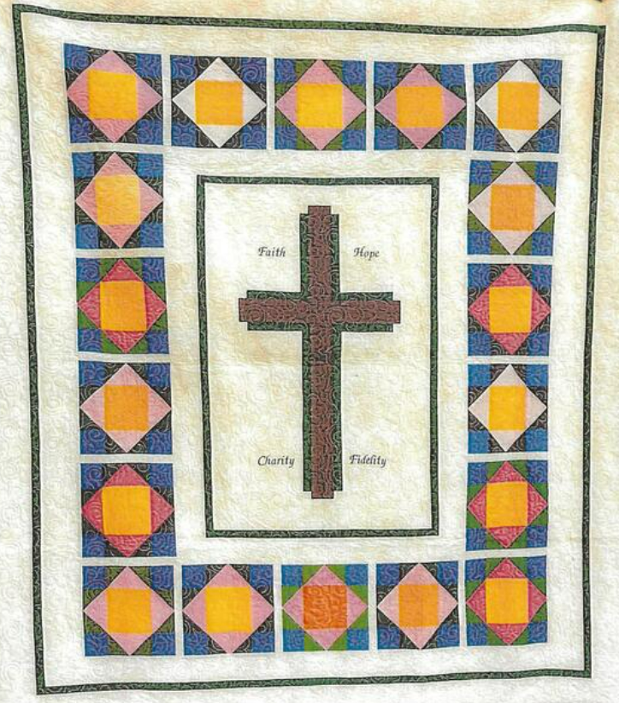
Class 3 Quilts entirely hand quilted by a group of Grangers
`
Division B Baby / Crib Quilt -min 34" x 38" max. 48" X 60"
Class 4 Hand Quilted
Class 5 Machine quilted

Division C Wall Hangings – maximum size 48" X 48"
Class 6 Hand quilted
Class 7 Machine quilted

Division D Machine Quilt - Minimum 60" X 60" maximum 120" X 120"
Class 8 Machine constructed and quilted, judge quilt top only

Division E Preprinted Top Quilt - Minimum 60" X 60" maximum 120" X 120"
Class 9 Pre-Printed Quilt Top, all work must be done by hand

- No precut quilt kits, No tied quilts.
- Quilted items must contain batting. You may use any brand quilt batting that you choose.
- All quilt contest items in Divisions A, B, C, D, and E are to be sent to State Session for judging. No Subordinate or Pomona elimination is necessary for this contest.
- Judging on TOP only!!
- Entries will be judged on workmanship, general appearance, and suitability of article for purpose.

2023 BAKING / COOKING CONTEST -- Attach the recipe to your entry label.

Class 10: Carrot Cake
Class 11: Gingerbread Cookies
Class 12: Chocolate Fudge

- Whole cake, 9” pan. Icing of your choice.
- Place 6 cookies on paper plate.
- Place 6 pieces of fudge on paper plate.
- Entries will be judged on texture and taste.
- All food articles must be made from scratch recipes. NO store mixes or store purchases can be used.
- After judging, entries will be the property of the FAC.

2022-2023 AFGHAN CONTEST

Full size (min. 42" x 55" max. 60" x 72") 2 Classes
Class 13A: Crochet; Class 13B - Knitted

Baby Afghan (max. size 45" x 45") 2 Classes
Class 14A: Crochet; Class 14B - Knitted

- Afghans can be knitted or crocheted with any brand of yarn you choose. NO machine work.
- Follow the gauge of yarn and needle to keep within the correct sizes for competition.
- Entries will be judged on workmanship, suitability of article and general appearance.

2022-2023 EMBROIDERY, CROSS STITCH, PLASTIC CANVAS

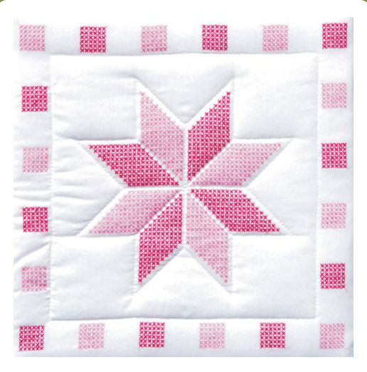
Class 15: Embroidery
15A – 12” & under
15B – over 12”
Class 16: Cross Stitch
16A – 12” & under
16B – over 12”
Counted Cross Stitch
16C – 12” & under
16D – over 12”
Class 17: Plastic Canvas Needlepoint

1. Class 15 and 16 you can use any brand floss you desire.
2. Class 17 you can use any brand of yarn you desire and there is no size restrictions.
- Entries will be judged on workmanship, general appearance and creativity.

2022-2023 COTTON THREAD CONTEST

Class 18: Doilies / Centerpieces

1. Must be hand crocheted, knitted or tatted with any brand of cotton crochet thread.
2. Entries will be judged on workmanship, suitability of article and general appearance.
2023 TIN PUNCHING

Class 19: Large Art (min 10”x10”, max 16”x16”)
Class 20: Small Art (under 10”x10”)

- Must be hand made by entrant, no kits
- Pattern and design of your choice
- Entries will be judged on workmanship, creativity, and general appearance.

2023 BELTS

Class 21: Women’s Belt
Class 22: Men’s Belt

- Can be made with any material (leather, cloth, beads, etc.)
- No size restrictions
- Entries will be judged on general appearance, workmanship, and creativity.
- Must be done by entrant, NO KITS.

2023 STENCILING

Class 23: Wood
Class 24: Slate
Class 25: Fabric
Class 26: Glass

- Can be design of your choice
- Any size up to 16”x20”
- Entries will be judged on general appearance, workmanship, and creativity.
- Must be done by entrant, NO KITS.

FAMILY ACTIVITIES COMMITTEE:
Cindy Schlegel, Co-Director; Evelyn Cottrell, Co-Director
TBA

